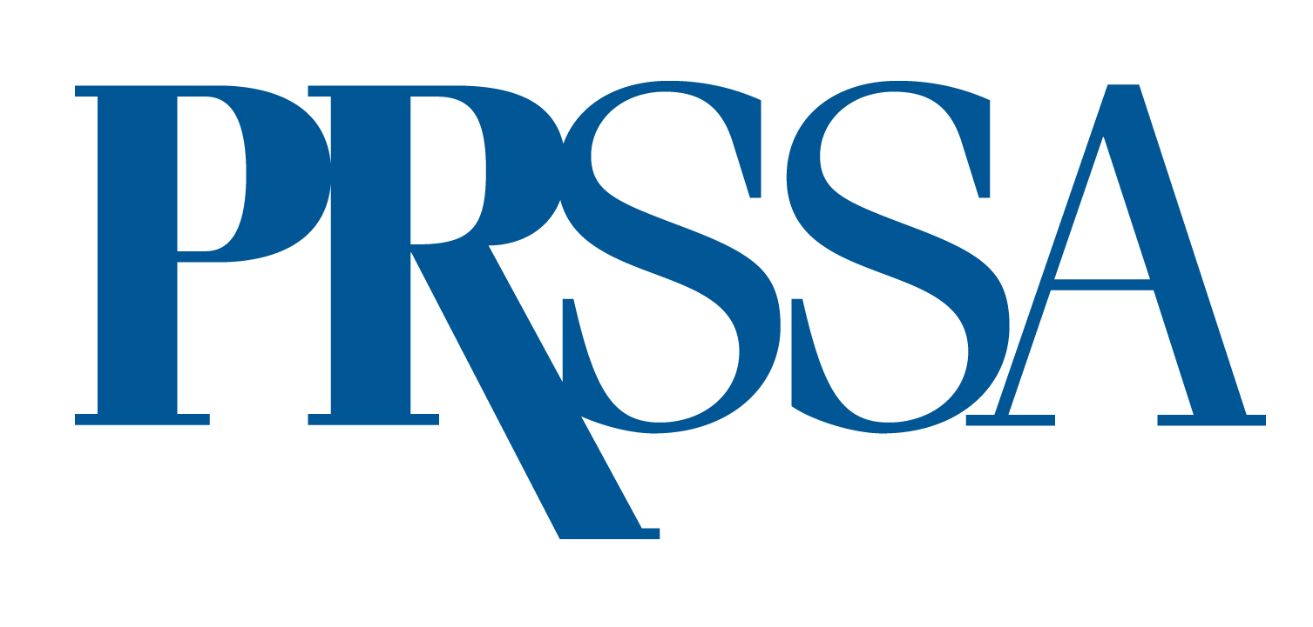

PRSSA 2023 Student-run Firm Awards
BEST CAMPAIGN or BEST TACTIC

The PRSSA Student-run Firm Campaign Awards recognize the top public relations work done by Nationally Affiliated Student-run Firms during the academic year, May 1, 2022–April 30, 2023.

To be eligible, a campaign or tactics must have been implemented at least in part between May 1, 2022 and April 30, 2023. Entries tend to have better chances of winning near their completion, when evaluation against initial objectives can be measured. For a student-run firm to be eligible, it must have current National Affiliation status. To be eligible, firms must have submitted a National Affiliation application by April 30, 2023 and be approved before the award application deadline.

To apply for a PRSSA Student-run Firm Award for best campaign or tactic, submit the following:
- Three-page Summary. This concise summary is the most important part of your entry and should give the judges a thorough view of the complete campaign or tactic.
For best campaign, the summary should cover research, planning, execution and evaluation, and may include a situation analysis, research, goals, objectives, strategies, tactics and results.
For best tactic, judges will evaluate your entry in four key areas — planning/content, creativity/quality, results and technical excellence (where applicable). Your summary should describe your measurable objectives, target audiences, budget and any other information specific to the tactic. Qualitative and quantitative results should show how you met the stated measurable objectives and how the entry impacted the success of a broader program.
- Samples. If you are applying for best campaign, submit samples of work created to support the overall objectives of the campaign. Samples may include research data, collateral materials, schedules, photographs and videos.
If you are applying for best tactic, enclose a sample of the tactic.
If a tactic or campaign element is online or video, include screen shots or printouts in addition to links or video files. Do not assume judges will have internet or computer access.
- 100-word Description. Include a 100-word description of your program. The description will be used to explain your entry if it receives the Best Campaign award.
- Application Form. Your application form, on Page 2 of this document, must be typed.

Entries must letter-size, with at least a 10-point font and 1” margins. Entries will be accepted in PDF format, with accompanying files attached at the end of the PDF.
All application materials must be included as attachments and sent via email to ben.castleman@prsa.org. All entries must be received by April 30, 2023. Winners will be announced at the PRSSA 2023 International Conference and receive a certificate.

Application Deadline: April.30, 2023
PRSSA 2023 Student-run Firm Awards
Application Form

I am applying for (select one):

- Best Tactic
- Best Campaign

School:

Name of Student-run Firm:

Number of Staff Members:

Name of Client:

Firm Director (student):

Address:

Phone:

Email:

Firm Adviser:

Address:

Phone:

Email:

Chapter Faculty Adviser:

Address:

Phone:

Email:

