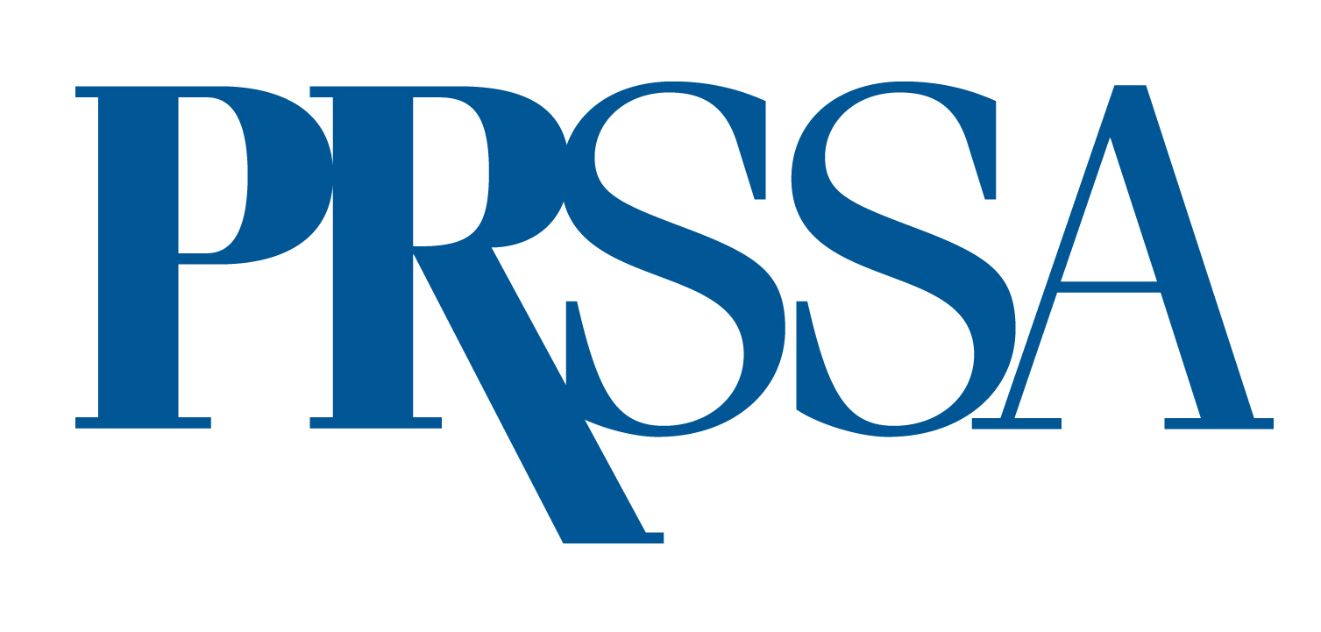

2024 National President's Citation

PRSSA strives for excellence in public relations, university service, community activities and professional development. A diverse group of students makes PRSSA the nation's preeminent pre-professional public relations organization. Many of these members go beyond expected service to the Society by contributing nationally or to Chapters in a meritorious way. The National President's Citation was created to celebrate and honor such members.

Every Chapter is encouraged to recommend outstanding members for this award. A maximum of two members per Chapter may receive a Citation. Recipients are a distinguished group within PRSSA.

Eligibility
To be eligible, you should possess leadership and professional skills, have a strong understanding of PRSSA and be an active member on the Chapter and national level. Every Chapter is encouraged to recommend any outstanding members for this award. No more than two members of a single Chapter will be chosen to receive a National President's Citation.

Application
Submit the following materials to apply for this award
- A completed application form
- A one-page essay. Discuss why you should be chosen to receive a citation based on your personal contributions to the success of your Chapter and describe how PRSSA membership has influenced your personal and professional development.
- A list of your PRSSA activities and honors.
- A signed letter of recommendation from your Faculty or Professional Adviser.
- (Optional) A one-page, typed, double-spaced, signed endorsement by a Chapter member.

Make sure all materials are error free and thoroughly proofread. All application materials must be included as attachments and sent via email to ben.castleman@prsa.org by April 30, 2024. Incomplete or late applications will not be considered.

Nomination Form

Name School

Class Status PRSA Sponsor Chapter

Phone Email

Full Address

Chapter President Phone

Faculty Adviser Phone

PRSSA Offices Held (if any)

Nominee plans to attend the 2024 International Conference Yes No

*Attendance is not part of the criteria to receive this award, solely for administrative purposes.

