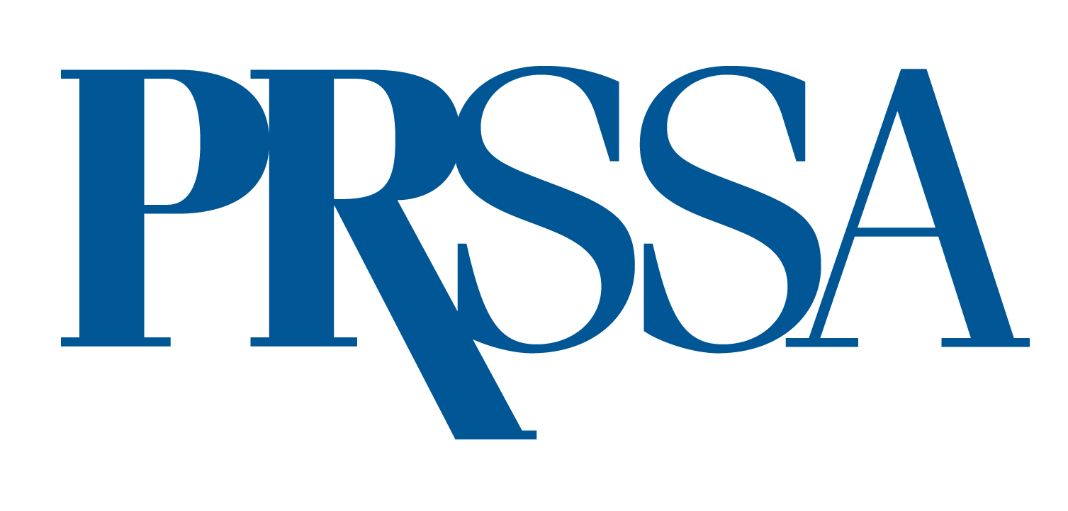
PRSSA 2024 International Conference Grant Application
Deadline: April 30, 2025

We encourage PRSSA students to apply for a PRSSA 2025 International Conference Grant. This grant will provide financial assistance to cover the registration fee for students wishing to attend the PRSSA 2025 International Conference. Up to ten grants will be awarded. The recipients will demonstrate superior writing skills in both the press release and the original essay required in the submission.

Eligibility and Application Requirements
To be eligible, you must be a current, paid PRSSA member planning to attend the PRSSA 2025 International Conference. Each applicant must submit the following materials (additional materials will not be considered):

- This application form, complete with signature from your PRSSA Faculty or Professional Adviser.
- A letter of recommendation of no more than 250 words from your PRSSA Faculty or Professional Adviser.
- A draft press release written by you of no more than 250 words announcing your selection as a PRSSA 2025 International Conference grant winner.
- An original essay written by you of no more than 250 words that addresses the following topic.
    - Pick one skill or trait that you consider essential for the next generation of new public relations professionals. Why is this skill or trait essential? What can new professionals do to strengthen this skill or trait?
Note: Do not pick more than one skill or trait. Your essay will be judged on your writing skills and defense of your ideas; not your selected skill or trait.

All materials (except for the signatures) must be typed. PRSSA will not accept incomplete applications. One grant application must be submitted per student. Chapters may not submit one application on behalf of multiple students. All application materials must be included as attachments and sent via email to ben.castleman@prsa.org by April 30, 2025.

Name Phone
Full Mailing Address
Email
Candidate's Signature
PRSSA Faculty or Professional Adviser's Name
PRSSA Faculty or Professional Adviser's Signature

