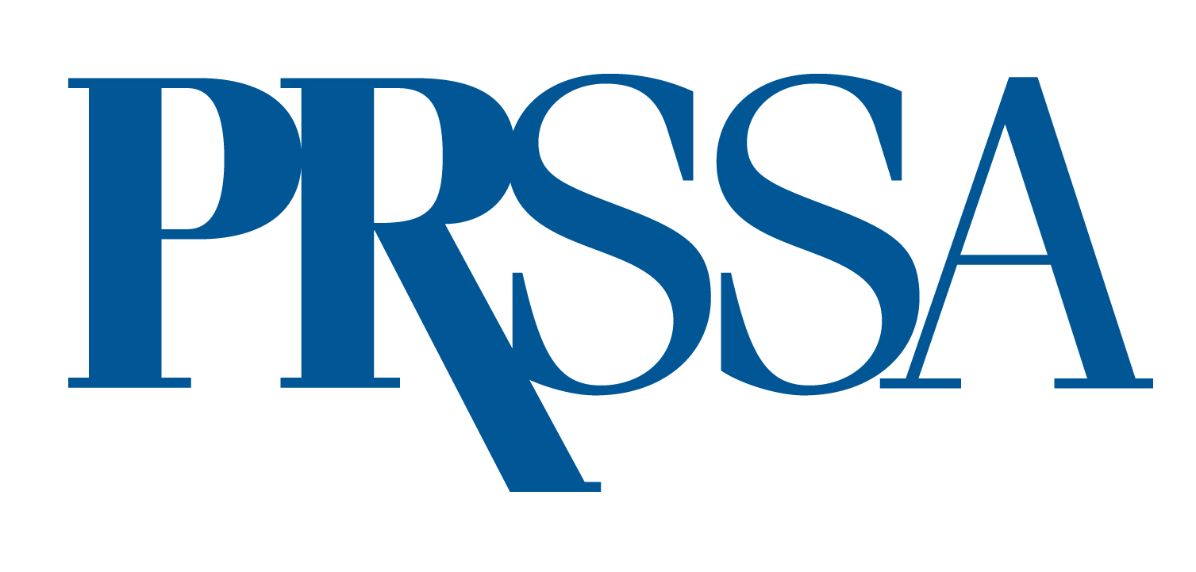
PRSSA BATEMAN COMPETITION SPONSOR
REQUEST FOR PROPOSALS FORM
Name:
Organization:
Mailing Address:
Telephone: Email:

Member of PRSA? ◻ Yes ◻ No Former Member of PRSSA? ◻ Yes ◻ No

The Bateman Case Study Competition Sponsorship fee is $40,000.
Can you provide this fee? ◻ Yes ◻ No

If another company has agreed to cover the sponsorship fee on your behalf, please provide contact information below.
Organization: Contact:
Mailing Address:
Telephone: Email:

Would you be interested in a multi-year sponsorship? ◻ Yes ◻ No

Would you be able to provide at least two representatives for the following? Yes No
- Initial Judging, April (date TBD)
Virtual
- Final Judging, May (date TBD)
Location to be determined by PRSSA and the client/sponsor.

By signing this form, I certify that the information submitted is completed to the best of my ability and has not been falsified in any way. Unsigned forms will not be accepted.
Candidate’s Name:
Candidate’s Signature:
Date:

This completed form must be emailed to jeneen.garcia@prsa.org by Monday, March 3, 2025

Bateman Case Study Proposal (500 words)
Briefly outline the project students will be addressing.

How will your proposal create opportunities for students to learn about and practice the four essential elements of a public relations campaign? (250 words)
Elements: Research, strategy and tactics, implementation and evaluation.
Please identify how this proposal and the project the students would undertake will strategically advance the goals and objectives of the organization. (100 words)
Please identify any charitable cause or social-responsibility issue addressed through this project. (150 words)

