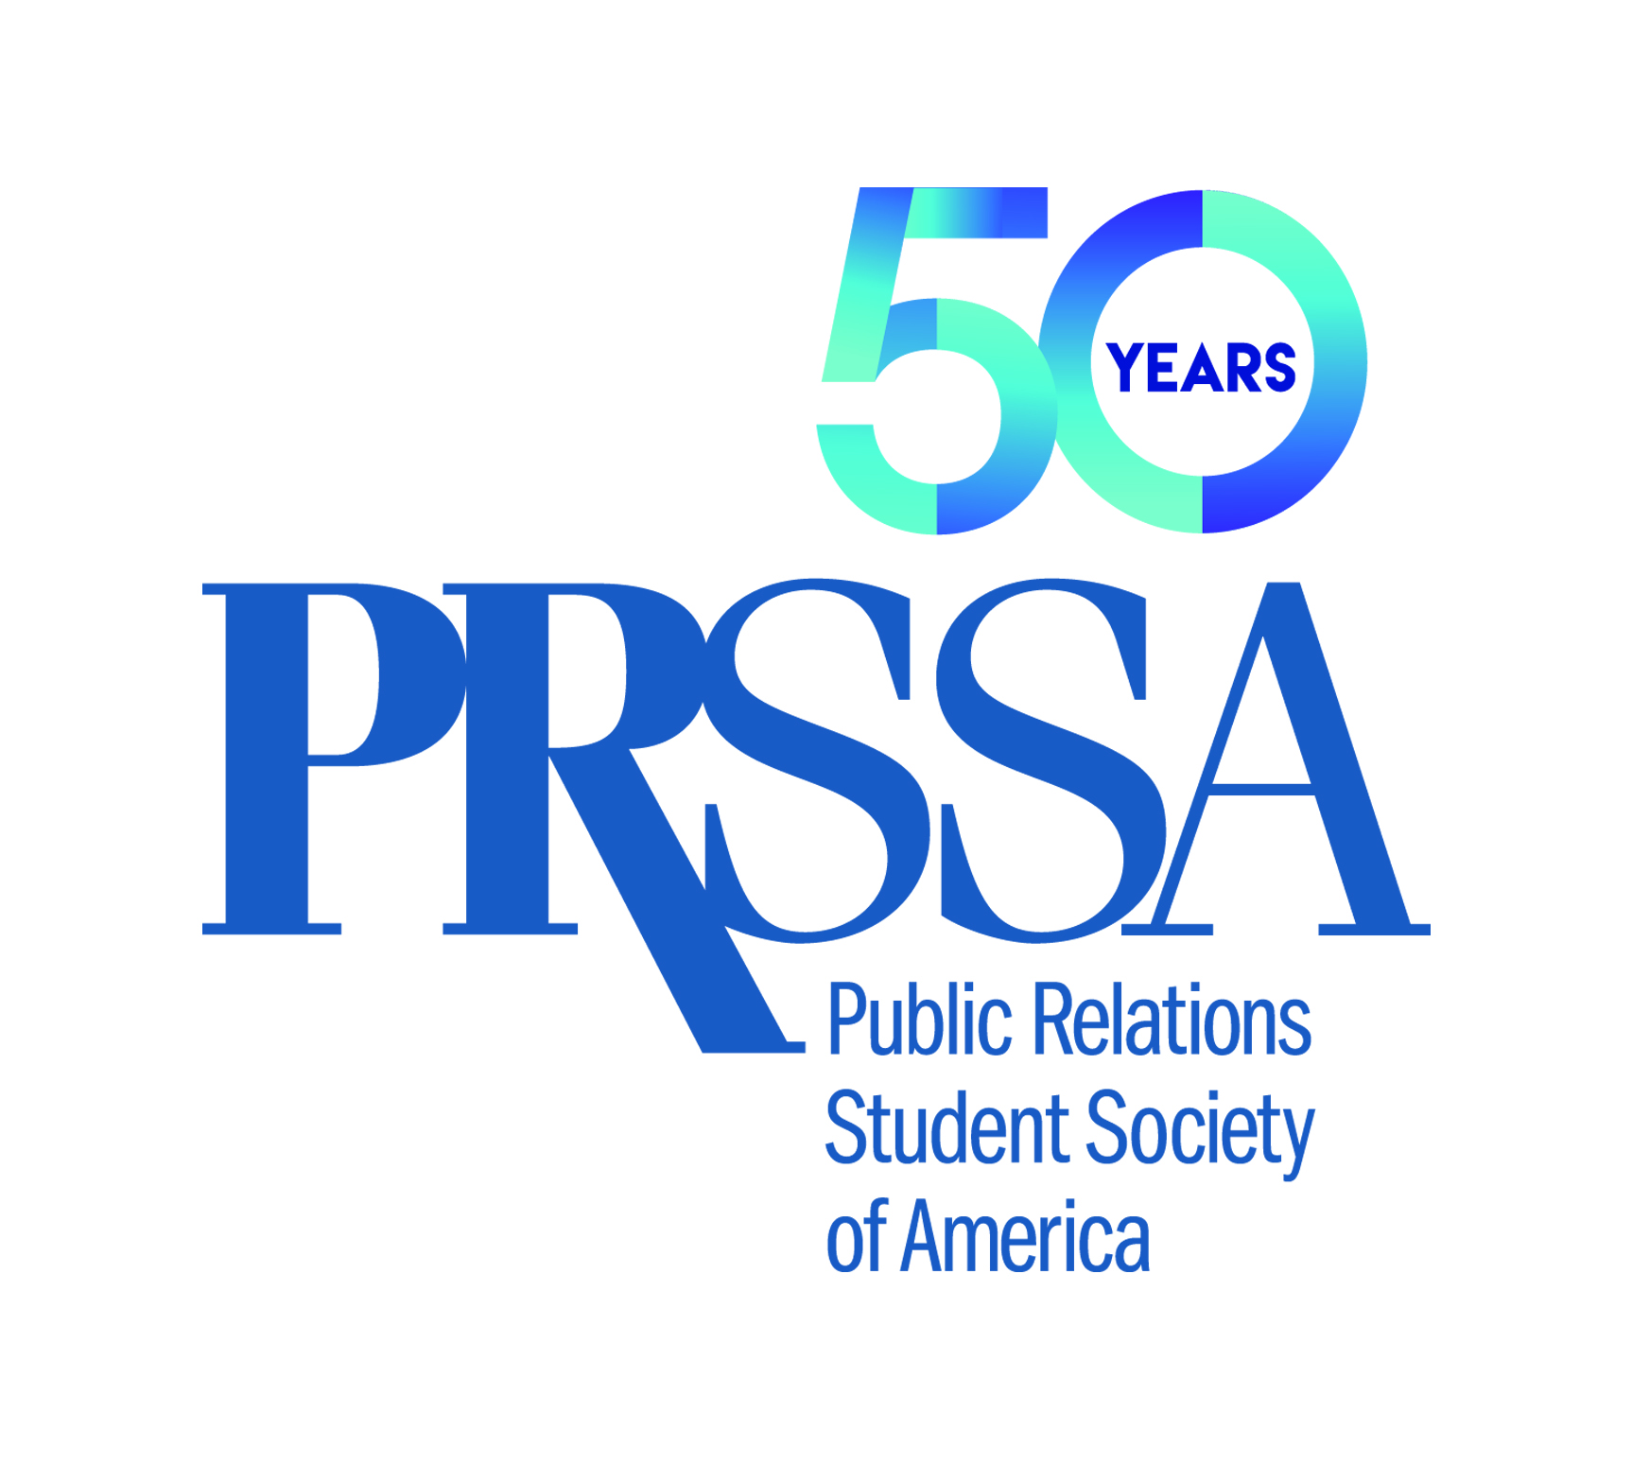
September 2018

TO: PRSSA Chapter Members
PRSSA Faculty Advisers

FROM: Jeneen Garcia, Executive Director, PRSSA

CC: Joseph P. Truncale, Ph.D., CAE, Chief Executive Officer, PRSA

RE: 2019 Bateman Case Study Competition

PRSSA is pleased to share the details of the 2019 Bateman Case Study Competition. This year, students are challenged to develop a campaign on behalf of the PRSA Foundation. The Society is committed to providing a stellar Competition that offers a relevant learning experience for all participants. Teams will be expected to create a well-thought-out public relations campaign, inclusive of research through evaluation.

Following the first round of judging, the three selected finalist teams will present their campaigns to be judged. All members of the finalist teams must be available for the final phase in May 2019. The logistics/administration of the Competition’s final phase will be determined in the spring of 2019.

The first-place team will receive $3,500 and a trophy; the second-place team will receive $2,500 and a plaque; and the third-place team will receive $1,500 and a plaque.

The Bateman Case Study Competition offers a unique and challenging experience. We believe this Competition will provide countless opportunities for participants to exercise creativity and originality in planning their campaigns.

PRSSA encourages all to enter this Competition. As one of the most challenging programs PRSSA offers, past teams have testified that the program provides an unmatched experience.

Please read the enclosed material carefully, and if you have questions, feel free to contact PRSSA National Headquarters at (212) 460-1476.

Enclosures: Project Brief
Rules and Guidelines
Timeline
Intent-To-Enter Form

