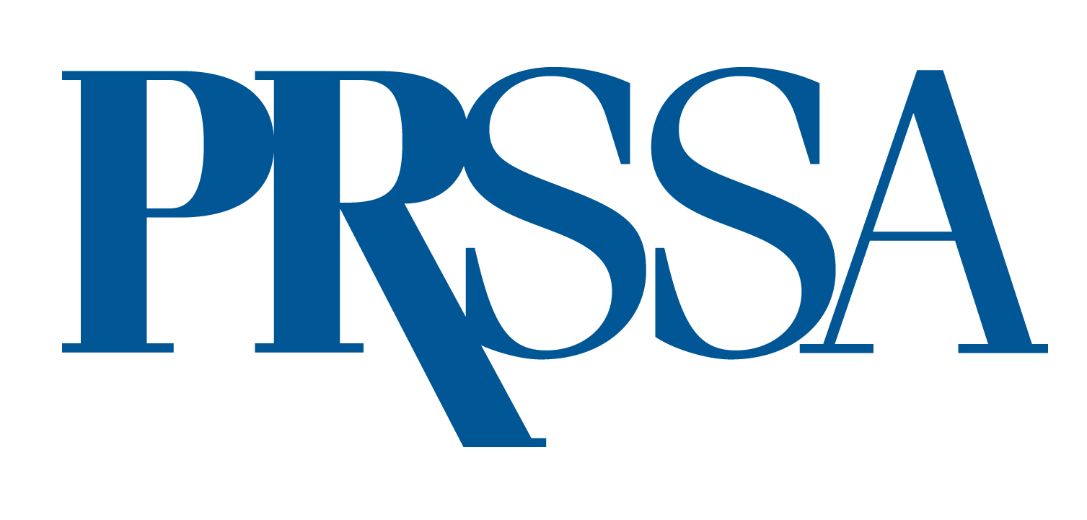
PRSA 2024 International Conference Grant Application
Deadline: April 30, 2024

We encourage former PRSSA members who have transitioned to PRSA Associate members to apply for a PRSA 2024 International Conference Grant. This grant will provide financial assistance to cover the registration fee for a former PRSSA member wishing to attend the PRSA 2024 International Conference. Up to eight grants will be awarded. The recipients will demonstrate superior writing skills in both the press release and the original essay required in the submission.

Eligibility and Application Requirements
To be eligible, you must be a current, PRSA Associate Member planning to attend the PRSA 2024 International Conference. Each applicant must submit the following materials (additional materials will not be considered):

- This application form, complete with your signature and signature from your PRSSA Faculty or Professional Adviser.
- A letter of recommendation of no more than 250 words from your PRSSA Faculty or Professional Adviser.
- A letter of recommendation of no more than 250 words from a current internship or job supervisor.
- A draft press release written by you of no more than 250 words announcing your selection as a PRSA 2024 International Conference grant winner.
- An original essay written by you of no more than 250 that addresses the following topic:
  - Why do you want to attend the PRSA 2024 International Conference? What do you hope to learn? How do you plan on sharing what you learned with fellow PRSA members?

All materials (except for the signatures) must be typed. Incomplete applications will not be accepted. One grant application must be submitted per member. All application materials must be included as attachments and sent via email to ben.castleman@prsa.org by April 30, 2024.

Name Phone
Full Mailing Address
Email
Candidate's Signature
PRSSA Faculty or Professional Adviser's Name
PRSSA Faculty or Professional Adviser's Signature

